Project Design Phase-II
Technology Stack (Architecture & Stack)

Date | 03 October 2026
Team ID | SWTID-2026-2035
Project Name | Implement Client Script & UI Policy (Incident)
Maximum Marks | 4 Marks

Technical Architecture:
The Deliverable shall include the architectural diagram as below and the information as per the table1 & table 2
Project-specific ServiceNow Incident architecture
Reference: ServiceNow platform architecture (project-specific)

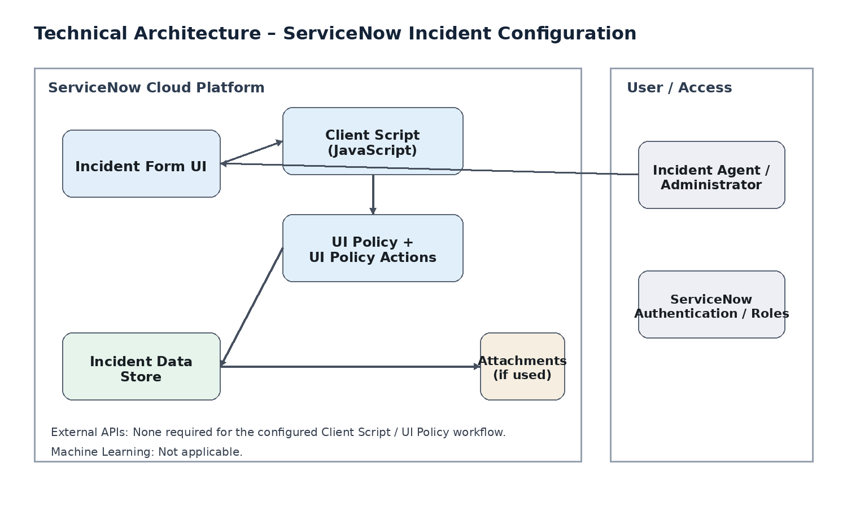
Guidelines:
Include all the processes (As an application logic / Technology Block)
Provide infrastructural demarcation (Local / Cloud)
Indicate external interfaces (third party API’s etc.)
Indicate Data Storage components / services
Indicate interface to machine learning models (if applicable)

Table-1 : Components & Technologies:
S.No | Component | Description | Technology
1 | User Interface | How the user interacts with the application | ServiceNow Incident form / Now Platform UI
2 | Application Logic-1 | Client-side logic for Incident form validation and field behavior | ServiceNow Client Script (JavaScript)
3 | Application Logic-2 | Conditional control of Incident field state | ServiceNow UI Policy
4 | Application Logic-3 | Actions applied to fields when UI Policy conditions are met | ServiceNow UI Policy Actions
5 | Database | Incident records and configuration data | ServiceNow platform data store
6 | Cloud Database | Managed platform data persistence | ServiceNow-managed cloud data store
7 | File Storage | Attachments associated with Incident records, if used | ServiceNow attachment storage
8 | External API-1 | External API required by the solution | None required
9 | External API-2 | External API required by the solution | None required
10 | Machine Learning Model | Machine-learning component used by the solution | Not applicable
11 | Infrastructure (Server / Cloud) | Application deployment and execution environment | ServiceNow cloud platform / SaaS

Table-2: Application Characteristics:
S.No | Characteristics | Description | Technology
1 | Open-Source Frameworks | No separate open-source framework is required; the solution uses native ServiceNow configuration features and JavaScript. | ServiceNow platform / JavaScript
2 | Security Implementations | Use authenticated ServiceNow access, roles and permissions, and platform access controls for administration. | ServiceNow roles / ACLs / authentication
3 | Scalable Architecture | Configuration is implemented within the ServiceNow platform; client-side rules can be extended to additional Incident fields without a separate application tier. | ServiceNow SaaS platform
4 | Availability | The solution is hosted within the ServiceNow instance, so the configured behavior is available with the platform service. | ServiceNow cloud platform
5 | Performance | Client-side validation and UI Policy behavior execute on the form and reduce unnecessary server-side processing for simple field rules. | Client Script / UI Policy

References:
https://c4model.com/
https://developer.ibm.com/patterns/online-order-processing-system-during-pandemic/
https://www.ibm.com/cloud/architecture
https://aws.amazon.com/architecture
https://medium.com/the-internal-startup/how-to-draw-useful-technical-architecture-diagrams-2d20c9fda90d

